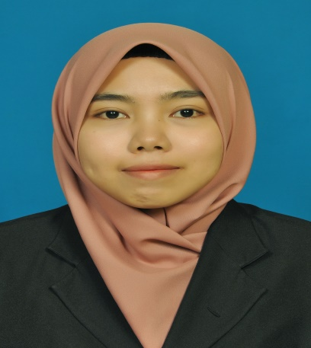

**AZANINA BINTI MOHD YUNOS**

019-4370062

[azanina_yunos93@yahoo.com](mailto:azanina_yunos93@yahoo.com)

No 11, Jalan Megah 35, Taman Megah,

82000 Pontian Johor.

|  |
| --- |
| **CAREER OBJECTIVES** |

* To apply for junior engineer position in an organization where high ability to cope with unfamiliarity and great analytical skills would be needed.
* Pursuing opportunity which allows me to grow professionally while utilizing and improving my skills to accomplish the organization’s requirements.

|  |
| --- |
| **PERSONAL QUALITIES** |

* Being a positive minded person and have good self-confident.
* Hardworking person,able to work in fast paced environment and work efficiently with self-discipline.
* Have a sense of responsibility and a very motivated person.
* Teamwork, well-managed organization structure, supportive and challenging working environment are part of my interest.
* Punctual and good leadership qualities.

|  |
| --- |
| **PERSONAL BACKGROUND** |

|  |  |
| --- | --- |
| Age : 23 | Gender : Female |
| Nationality : Malaysian | IC No. : 930318-01-5044 |
| Marital Status: Single | Religion : Islam |
| Date of Birth : 18 March 1993 | License : B2,D |

|  |
| --- |
| **EDUCATION** |

**Bachelor**

Field of Study : Bachelor of Communication Engineering (Honour)

Institute : University Malaysia Perlis (UniMAP)

Graduation Date : 22 October 2016

Current CGPA : 3.17/4.00

**Pre-University**

Field of study : Biological Science

Institute : Pusat Asasi Sains UM (PASUM)

Finish Date : 30 April 2012

CGPA : 2.81/4.00

**Sijil Pelajaran Malaysia (SPM)**

School : MRSM Serting

Finish Date : 31 December 2010

Grade : 7A2B1C

|  |
| --- |
| **EXPERIENCES AND WORKS** |

**Scrap Computer Trading (SCT)**

Position Title : Industrial Trainee (Maintenance Service)

Format computer and laptop, managing data and information,

upgrade processor, finishing task from customer.

Duration : Jun-September 2015

**McDonalds Pontian, Johor**

Position Title : Crew

Duration : May-August 2012

**7 Elevent Pontian, Johor**

Position Title : Assistant Store

Duration : January-April 2011

**Final Year Project (FYP)**

Title : Design microstrip bandpass filter using open-circuited stub

(This project involves the design of microstrip bandpass filter by using open-circuited stub technique. This filter can be useful in many

applications in telecommunications such as WIFI, Wimax, mobile phone, in radar, military application, medical instrumentation and other field.

**Group Design Project (GDP)**

Title : Embedded Cruise Controller

(This project involves the design of embedded cruise controller system

which aimed for making driving convenient for car drivers and to improve

road safety.

|  |
| --- |
| **LANGUAGE SKILLS** |

Languages (Proficiency : Excellent = 10 – Fair = 1)

|  |  |  |
| --- | --- | --- |
| **Languages** | **Written** | **Spoken** |
| Bahasa Malaysia | 10 | 10 |
| English | 8 | 7 |

|  |
| --- |
| **ADDITIONAL SKILLS** |

|  |  |
| --- | --- |
| **Software Skills** | **Engineering Technical Skills** |
| * Microsoft Word * Basic in Orcad * Computer Programming * Quartus II * Advanced Design Software (ADS) * CST Studio | * Basic in Arc Welding (Beginer) * Basic Electrical Wiring (Beginer) * Basic Engineering Drawing (Beginer) * Basic PCB Fabrication (Beginer) |

|  |
| --- |
| **ACHIEVEMENTS AND AWARDS** |

**Academic**

Recipient of Dean’s List Award for **Semester 1 2013/2014** with GPA of 3.70

Recipient of Dean’s List Award for **Semester 1 2015/2016** with GPA of 3.54

**Co-Curriculum**

2012-2014 : Interfaculty Sports

2013 : SCCE Competition (Futsal)

2014 : SCCE Competition (Futsal and Volleyball)

|  |
| --- |
| **REFERENCES** |

**1. Dr. Muzammil bin Jusoh**

Senior Lecturer,

School of Computer and Communication

Engineering (SCCE),

Universiti Malaysia Perlis (UniMAP),  
 Pauh Putra Campus,  
 02600 Arau, Perlis.

E-mail: [muzammil@unimap.edu.my](mailto:muzammil@unimap.edu.my)

**2. Pn. Nordiana binti Mohamad Saaid**

University Lecturer,

School of Computer and Communication

Engineering (SCCE),

Universiti Malaysia Perlis (UniMAP),  
 Pauh Putra Campus,  
 02600 Arau, Perlis.

Phone : 012-5323598

E-mail: [dianams@unimap.edu.my](mailto:dianams@unimap.edu.my)